Re-Wireable Male Inline Plug 16 Amps @ 250V - Commando (PWR-CMD-P12341)

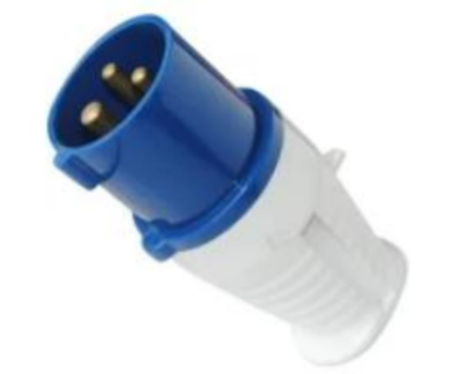

Description:

The LMS Power PWR-CMD-P12341 is a high quality, IP44 rated and completely
re-wireable 16 Amp Commando plug used for very high electrical load applications.
The standard design used for power generation, power distribution extensions and other appliances that need the larger 16 Amp conformance standard.
Quality build assured, 16 Amp rated nickel pole design together with a large cable entry cross-section.

Key Features:
Standardised Commando Plug
Rated at up to 16 Amps up to 250 Volts
Fully re-wireable with screen down terminals
IP44 Weather proof rating

Applications:
Create bespoke electrical connections electrical systems
Create electrical connections for very high power appliances
Needed when separate electrical circuits are required

Product Code:
Part Number: PWR-CMD-P12341
EAN: 8400800037886
Weight: 0.1Kg approx

Technical Specifications:
Warranty LMS Data 2-Year Warranty
Chassis Thermoplastic, screw down housing
Load 16 Amps 250 Volts (Nominal)
Poles/Hours 2P+E/6H
Standards CE, Intertek Certified
Cable Entry 6mm-12mm (approx)

Supplied With:
PWR-CMD-P12341 Commando Plug
* Specifications and product design are subject to change. E&OE.

